
Bureau Veritas Hong Kong Limited
TEST REQUEST FORM FOR TOYS/JUVENILE PRODUCTS

 | Quotation required before testing(testing only starts upon signed quotation received at BVHK with complete information and samples)
Your Company Name |  |  |  |  |  |  |  |  |  |  |  |  |  |  |  |  |  |  |  |  |  |  |  |  |  |  |  |  |  |  |  |  |  |  |  |  |  |  |  |  | (JDE No. |  |  |  | )
Address
Company Name & Address in Chinese (if your company is in China)
Contact Person |  |  |  |  |  |  |  |  |  |  |  |  |  |  |  |  |  | Tel No. |  |  |  |  |  |  |  |  |  |  |  |  |  |  | (Ext ) |  |  |  |  | Fax No.
 |  |  |  |  |  |  |  |  |  |  |  |  |  |  |  |  |  | e-mail address:
Report and invoice will state the above company name & contact person: If not, please advise
Report To: Company |  |  |  |  |  |  |  |  |  |  |  |  |  |  |  |  |  | Contact Person |  |  |  |  |  |  |  |  |  |  |  |  |  |  |  |  |  | Tel No.
Address |  |  |  |  |  |  |  |  |  |  |  |  |  |  |  |  |  |  |  |  |  |  |  |  |  |  |  |  |  |  |  |  |  |  |  | Fax No.
Company Name & Address in Chinese (if your company is in China)
Invoice To: Company |  |  |  |  |  |  |  |  |  |  |  |  |  |  |  |  |  | Contact Person |  |  |  |  |  |  |  |  |  |  |  |  |  |  |  |  |  | Tel No.
Address |  |  |  |  |  |  |  |  |  |  |  |  |  |  |  |  |  |  |  |  |  |  |  |  |  |  |  |  |  |  |  |  |  |  |  | Fax No.
Company Name & Address in Chinese (if your company is in China)
Sample Description
UPC
No. of sample submitted |  |  |  |  |  |  |  |  |  |  |  |  |  |  |  |  |  |  |  |  | Buyer/Submitting For
Style/Item No. |  |  |  |  |  |  |  |  |  |  |  |  |  |  |  |  |  |  |  | Assortment No.
P.O. No. |  |  |  |  |  |  |  |  |  |  |  |  |  |  |  |  |  |  |  |  |  | SKU/SKN No.
Vendor |  |  |  |  |  |  |  |  |  |  |  |  |  |  |  |  |  |  |  |  |  | Manufacturer
Country of Origin |  |  |  |  |  |  |  |  |  |  |  |  |  |  |  |  |  |  |  | Country of Destination
If this is a Retest, please state previous test report No.

TEST REQUESTED (Please ✓tick where appropriate) (Labeled Age Grade will be used for testing if no instruction is given)
State Age Grade used for testing: |  |  |  |  |  |  |  |  |  |  |  |  |  |  |  |  |  |  |  |  |  |  |  |  |  |  |  |  |  |  |  | OR Age Grade determined by BVHK
US |  |  |  |  |  |  |  |  |  |  |  |  |  |  |  |  |  |  |  |  |  |  |  | Europe
ASTM F963-16 Mechanical hazards – Toys |  |  |  |  |  |  |  |  |  |  |  |  |  |  |  |  |  |  |  |  |  |  |  | EN 71 Pt.1-14 Mechanical hazards |  |  |  |  |  |  |  |  |  |  |  |  |  | For textile toy intended for under 3 years of age:  No wash Test after wash  Test before & after wash

16 CFR 1500.44 Flammability (solids)
16 CFR 1610 Flammability (clothing textiles) / (costume) |  |  |  |  |  |  |  |  |  |  |  |  |  |  |  |  |  |  |  |  |  |  |  | EN 71 Pt.2-11 + A1:2014 Flammability

16 CFR 1611 Flammability (vinyl plastic film)
ASTM F963-16 Fabric Flammability - Toys |  |  |  |  |  |  |  |  |  |  |  |  |  |  |  |  |  |  |  |  |  |  |  | EN 71 Pt.3 Heavy metals content
ASTM F963-16 heavy metals requirement |  |  |  |  |  |  |  |  |  |  |  |  |  |  |  |  |  |  |  |  |  |  |  | EN 71 Pt.9 Organic chemical compounds
ASTM F963-16 4.25.11 Rechargeable battery |  |  |  |  |  |  |  |  |  |  |  |  |  |  |  |  |  |  |  |  |  |  |  | EC No.1907/2006 Annex 17 Cadmium content
 |  |  |  |  |  |  |  |  |  |  |  |  |  |  |  |  |  |  |  |  |  |  |  | EC No.1907/2006 Annex 17 Amines (azodyes) content
CONEG (Packaging Material Regulation) |  |  |  |  |  |  |  |  |  |  |  |  |  |  |  |  |  |  |  |  |  |  |  | EC No.1907/2006 Annex 17 Nickel release (skin contact)
USP 51 Preservative effectiveness |  |  |  |  |  |  |  |  |  |  |  |  |  |  |  |  |  |  |  |  |  |  |  | EC No.1907/2006 Annex 17 Nickel release (piercing post)
USP 61 Microbial limit test |  |  |  |  |  |  |  |  |  |  |  |  |  |  |  |  |  |  |  |  |  |  |  | EN 62115 Electric toys safety + A2 + A11
USP 61/62 Microbiological examination |  |  |  |  |  |  |  |  |  |  |  |  |  |  |  |  |  |  |  |  |  |  |  | EN 62115 Electric toys safety + A2 + A11+A12
ASTM F963 Total plate count & total coliform |  |  |  |  |  |  |  |  |  |  |  |  |  |  |  |  |  |  |  |  |  |  |  | EN 60825-1 Class 1 LED
ASTM F963-16 8.4.1 cleanliness of materials / Feathe |  |  |  |  |  |  |  |  |  |  |  |  |  |  |  |  |  |  |  |  |  |  |  | EMC Test for B/O electronic toys
16 CFR 1505 Electrically operated toys |  |  |  |  |  |  |  |  |  |  |  |  |  |  |  |  |  |  |  |  |  |  |  | RoHS Compliance test (XRF + wet chem)
21 CFR 700.13 Mercury in cosmetics |  |  |  |  |  |  |  |  |  |  |  |  |  |  |  |  |  |  |  |  |  |  |  | EN 50419 Marking of WEEE 2002/96/EC with rubbing without rubbing
PA Stuffed Toy Law (47.317) Tolerance |  |  |  |  |  |  |  |  |  |  |  |  |  |  |  |  |  |  |  |  |  |  |  | EC Directive 94/62/EC Heavy metals
 |  |  |  |  |  |  |  |  |  |  |  |  |  |  |  |  |  |  |  |  |  |  |  | EC No.1907/2006 BBP/DBP/DEHP/ DNOP/DINP/DIDP content
 |  |  |  |  |  |  |  |  |  |  |  |  |  |  |  |  |  |  |  |  |  |  |  | Europe TSD 2009/48/EC
US CPSIA 2008 |  |  |  |  |  |  |  |  |  |  |  |  |  |  |  |  |  |  |  |  |  |  |  | EU NTSD Safety assessment with PCP without PCP
CPSIA BBP/DBP/DEHP/DNOP/DINP/DIDP content |  |  |  |  |  |  |  |  |  |  |  |  |  |  |  |  |  |  |  |  |  |  |  | NTSD Technical File Consultation Repository Review & Validation
no composite composite |  |  |  |  |  |  |  |  |  |  |  |  |  |  |  |  |  |  |  |  |  |  |  | Internal Production Control
CPSIA Total lead content in surface coating / 16 CFR 1303 (Limit ≤ 90 ppm) |  |  |  |  |  |  |  |  |  |  |  |  |  |  |  |  |  |  |  |  |  |  |  | – Previous Safety Assessment and/or FCMS Report#
no composite composite |  |  |  |  |  |  |  |  |  |  |  |  |  |  |  |  |  |  |  |  |  |  |  | Final Random Inspection (FRI)
CPSIA Total lead content in substrate (Limit ≤ 100 ppm) |  |  |  |  |  |  |  |  |  |  |  |  |  |  |  |  |  |  |  |  |  |  |  | Factory Chemical Management System Assessment (FCMS)
no composite composite |  |  |  |  |  |  |  |  |  |  |  |  |  |  |  |  |  |  |  |  |  |  |  | Australia
CPSIA Total lead in Children metal jewelry |  |  |  |  |  |  |  |  |  |  |  |  |  |  |  |  |  |  |  |  |  |  |  | AS/NZS ISO 8124.1 Mechanical hazards
 |  |  |  |  |  |  |  |  |  |  |  |  |  |  |  |  |  |  |  |  |  |  |  | AS/NZS ISO 8124.2 Flammability
Canada |  |  |  |  |  |  |  |  |  |  |  |  |  |  |  |  |  |  |  |  |  |  |  | AS/NZS ISO 8124.3 Heavy metal content

CCPSA Mechanical hazards
CCPSA Magnet |  |  |  |  |  |  |  |  |  |  |  |  |  |  |  |  |  |  |  |  |  |  |  | ISO
CCPSA Flammability  CCPSA Heavy metal |  |  |  |  |  |  |  |  |  |  |  |  |  |  |  |  |  |  |  |  |  |  |  | ISO 8124 Pt.1 Mechanical hazards
CCPSA Surface Coating Materials Regulations, SOR/2005-109 |  |  |  |  |  |  |  |  |  |  |  |  |  |  |  |  |  |  |  |  |  |  |  | ISO 8124 Pt.2 Flammability
CCPSA Consumer Products Containing Lead (Contact with Mouth) Regulations,  SOR/2010-273 |  |  |  |  |  |  |  |  |  |  |  |  |  |  |  |  |  |  |  |  |  |  |  | ISO 8124 Pt.3 Heavy metal content
CCPSA Phthalates Regulation BBP/DBP/DEHPDNOP/DINP/DIDP content |  |  |  |  |  |  |  |  |  |  |  |  |  |  |  |  |  |  |  |  |  |  |  | Issue HOKLAS Report  Issue Product image on report

CCPSA Children’s Jewellery Regulation SOR/2011-19

CPSIA General Conformity Certificate (GCC)/Children’s Products Certificate (CPC) Package

CPSIA Applicable rules review & CPSIA GCC/CPC Issuance.(Please fill in the “CPSIA General Conformity Certificate)/Children’s Products Certificate And Third Party Report Additional Information Form” for the person maintaining test records in support of the certification.)

Others
Service Required: |  |  |  |  |  |  |  | Regular |  |  |  | Next Four Day (40% surcharge) |  |  |  |  |  |  | Next Two Day (100% surcharge) |  |  |  |  |  |  |  |  |  |  |  |  |  |  |  | Next Day (150% surcharge)
Express (150% surcharge for some selected tests with longer testing times) Same Day (200% surcharge) ** Minimum Report Charge HKD200 **
Return Sample: |  |  |  |  |  |  |  | No |  |  |  |  | Self Collect Failed Samples |  |  |  |  |  |  |  |  |  |  |  |  |  | Self Collect Tested Samples
Return Failed Samples (At cost for overseas - please provide courier Account No. |  |  |  |  |  |  |  |  |  |  |  |  |  |  |  |  |  |  |  |  |  |  |  | )
Sample Pick up Hotline: 2331-0333 (Monday to Saturday) Customer Service Hotline: 2331-0222 (Monday to Friday)
Date |  |  |  |  |  |  |  |  |  |  |  |  |  |  | Authorized Signature and Company Chop

FOR LABORATORY INTERNAL USE ONLY
Date Received |  |  |  |  |  |  |  |  |  |  |  |  |  |  |  |  | Received By |  |  |  |  |  |  |  |  |  |  |  |  |  |  |  |  | Sample No
Bureau Veritas Hong Kong Limited  Kowloon Bay Office  1/F, Pacific Trade Centre, 2 Kai Hing Road, Kowloon Bay, Kowloon  Tel: 2331-0888 Fax: 2331-0889 Website: www.bureauveritas.com/cps |  |  |  |  |  |  |  |  |  |  |  |  |  |  |  |  |  |  |  |  |  |  |  |  |  |  |  |  |  |  |  |  |  |  |  |  | PLEASE SUBMIT YOUR SAMPLES TO  2/F, Pacific Trade Centre
CPSD-TY-TRFS-KB-TOYS JP CHILD CARE ARTICLES-V36.doc Page 1 of 2 Version# 36 Revision Date: April 23, 2015
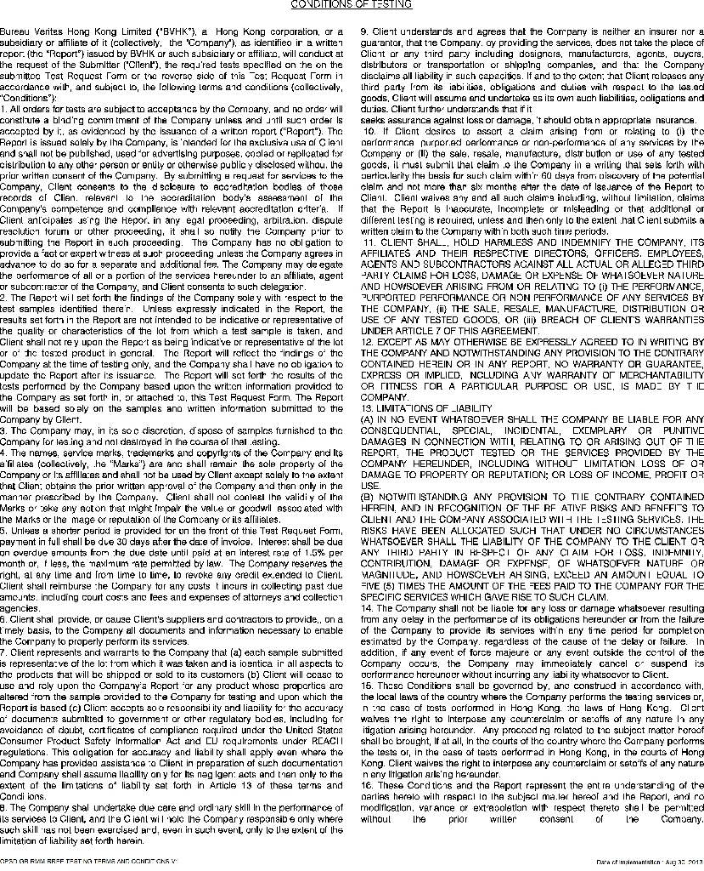
CPSD-TY-TRFS-KB-TOYS JP CHILD CARE ARTICLES-V36.doc Page 2 of 2 Version# 36 Revision Date: April 23, 2015

